FR. Conceicao Rodrigues College of Engineering
Department of Computer Engineering

1. Addition of Two 8/16/32 bit numbers

1. Course, Subject & Experiment Details

Academic Year | 2023-24 | Estimated Time | Experiment No. 1– 02 Hours
Course & Semester | S.E. (Comps)  – Sem. IV | Subject Name | Microprocessor
Chapter No. | 2 | Chapter Title | Instruction Set and Programming
Experiment Type | Software | Subject Code | CSC405

Rubrics
Timeline (2) | Practical Skill & Applied Knowledge  (2) | Output  (3) | Postlab  (3) | Total  (10) | Sign

2. Aim & Objective of Experiment
TO ADD TWO 8/16/32 BIT NUMBERS
Objective : Program involves storing the two 8-bit no in memory locations and adding them taking into consideration the carry generated. The objective of this program is to give an overview of arithmetic instructions of 8086 for 8-bit operands

3. Software Required

TASM Assembler

4 . Brief Theoretical Description

Pre-Requisites: 1. Instructions of microprocessor 8086
2. Addressing mode of microprocessor 8086.
3. Knowledge of TASM directories.

Theory: The addressing modes used in program are:
1) Direct addressing mode: in this mode address of operand is directly specified in the instruction. This address is offset address of the segment being indicated by an instruction.
E.g. MOV AL,[2000h]
EA = DS x 10H + 2000H
2) Register Addressing Mode: In this mode operand are specified using registers. Instructions are shorter but operations cannot be identified looking at instruction.
E.g. MOV CL, DL
3) Based Indexed Addressing Mode: The operand address is calculated using base register and index register.
E.g. MOV DX, [BX + SI] moves word from address pointed by BX + SI in data segment to DX.
EA = DS x 10H + BX + SI
4) Base indexed plus displacement: In this mode address of operand is calculated using base register , index register and displacement.
E.g. MOV CX, [BX+DI+10h]
This moves a word from address pointed by BX + DI +10h of segment to CX.
5. Algorithm: 1. Initialize the data segment.
2. Store two 8/16 -bit numbers in memory locations.
3. Move the 1st number in any one of the general purpose register.
4. Move the 2nd number in any other general purpose register.
5. Add the 2 numbers.
6. Store the result in memory location.
7. Check for carry flag. If carry flag is set then store '1' as
MSB of result.
8. Stop

6. Conclusion:

8 bit addition:-
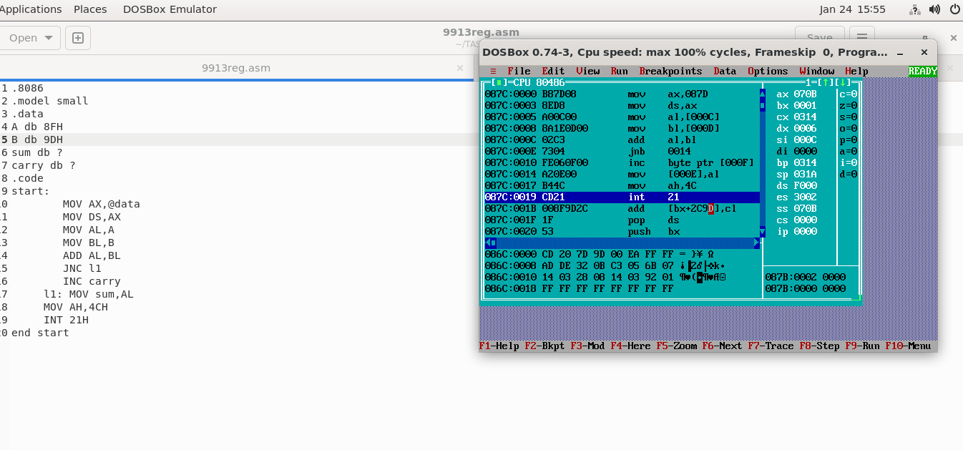

16 bit addition:-
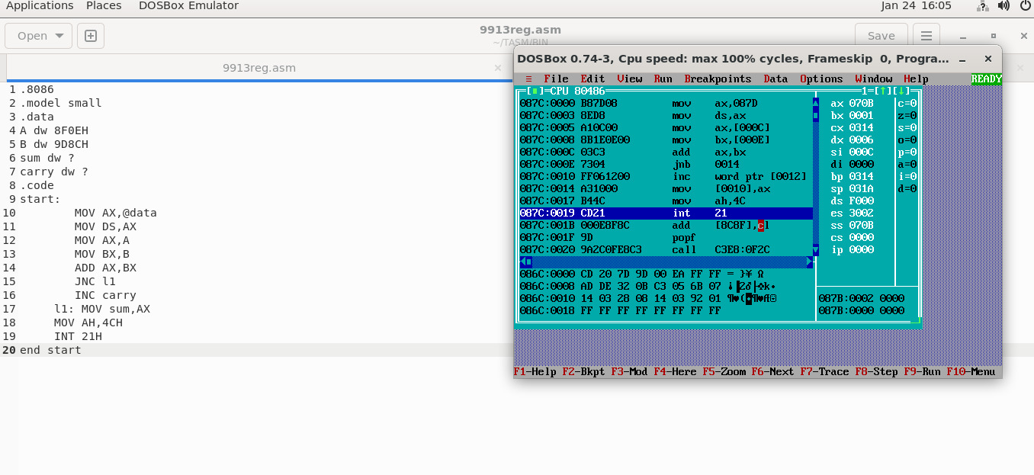

Postlab:
- Write a program for addition of two 32 bit numbers ,execute and take the screen shots of the results.

.8086
.model small
.data
num1 dd 12345678H
num2 dd 12345678H
suml dw ?
sumh dw ?
.code
start:
MOV AX, @data
MOV DS, AX
LEA SI, num1
MOV AX, [SI]
MOV BX, [SI+04H]
ADC AX, BX
MOV suml, AX

MOV AX, [SI+02H]
MOV BX, [SI+06H]
ADC AX, BX
MOV sumh, AX
MOV AH, 46H
INT 21H
end start
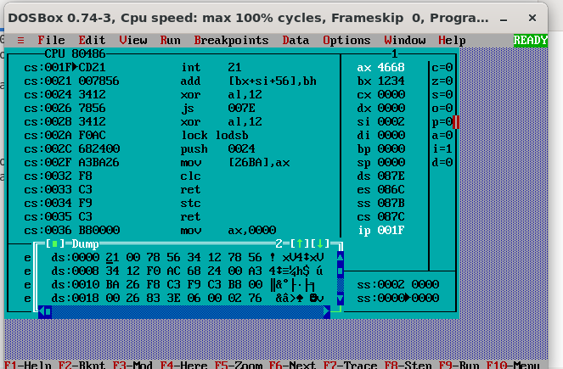

- Write a program to Subtract two 16 bit numbers.

.8086
.model small
.data
A dw 2456H
B dw 3280H
subt dw ?
burrow dw ?
.code
start:
MOV AX, @data
MOV DS, AX
MOV AX, A
MOV BX, B
SBB BX, AX
JNC skip
INC burrow
skip: MOV subt, BX
MOV AH, 4CH
INT 21H
end start

